EXPERIEMNT 19: - Install a C compiler in the virtual machine created using virtual box / VM Ware Workstation / Player and execute Simple C Programs.

Step 1: - Open the existing virtual machine

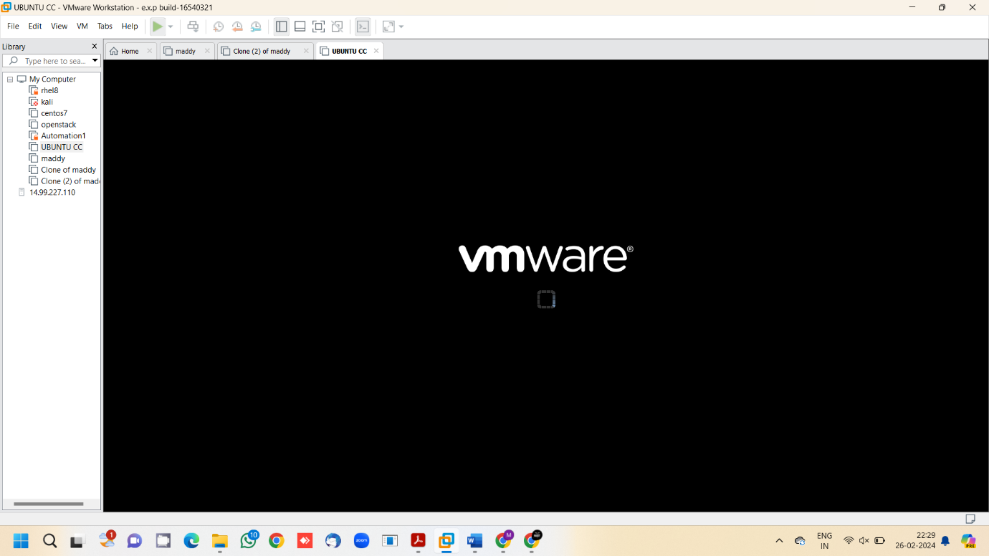

Step 2: - Type your desired c program and save it.

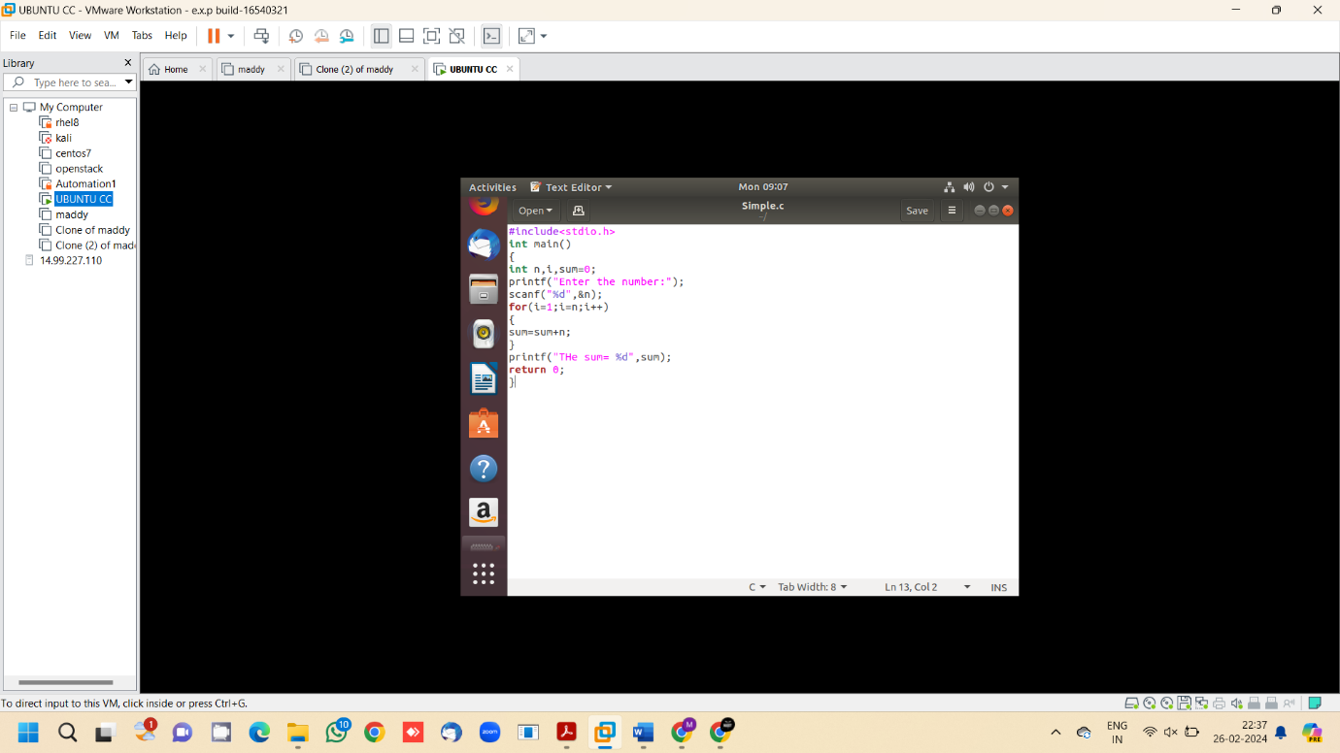

Step 3: - Open terminal

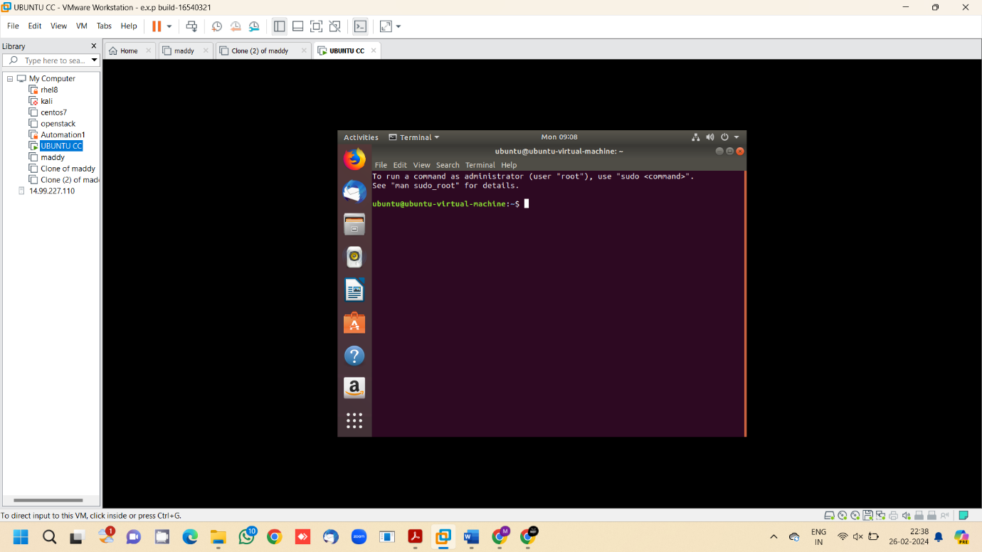

Step 4: - Execute the c program using terminal

